Invoice: Web3D Consortium Medical Working Group

Project:

TATRC: X3D + Medical Ontology Integration

Invoice Date: August 1, 2007

_____________________________________________________________

Contract Record Sheet

Milestones Completed

Phase 1:
Initiate project and archiving system
Survey of Semantic Web technologies, Medical ontologies
Foundational Model of Anatomy (FMA) development environment (protégé)
SNOMED development environment (protégé)
Initial database translation
= $ 3,750.00

.

Expenses
$ 0

+

TOTAL: $ 3,750.00
Payable to ‘VirtuWorlds’

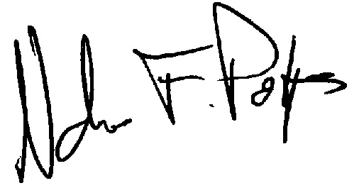
Nicholas F. Polys

