Invoice: Web3D Consortium Medical Working Group

Project:

TATRC: X3D + Medical Ontology Integration

Invoice Date: September 22, 2007

_____________________________________________________________

Contract Record Sheet

Milestones Completed

Phase 2:
Fork cases: external reference of ontologies vs. in-scenegraph representation
X3D Metadata evaluation: develop and assess mappings (FMA, SNOMED)
Formulation of mapping rules (FMA, SNOMED)
Initial XSLT implementation (FMA)

= $ 3,750.00

.

Expenses
$ 0

+

TOTAL: $ 3,750.00
Payable to ‘VirtuWorlds’

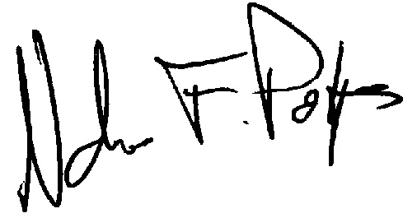
Nicholas F. Polys

